Digital Logic Design

(EL-1005)
LABORATORY MANUAL
Spring-2026


LAB 01
Introduction to DLD, Lab Tools & Basic Logic Gates

STUDENT NAME ROLL NO SEC

INSTRUCTOR SIGNATURE & DATE

MARKS AWARDED: /10

NATIONAL UNIVERSITY OF COMPUTER AND EMERGING SCIENCES (NUCES), KARACHI

Lab Task:

Lab Task#1:

Implement the following logic circuit on logic trainer/logic work (attach screenshot below), and write truth table in the space provided below:
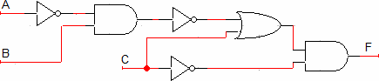
Figure 24: Combinational Circuit

Lab Task#2
Draw the logic circuit represented by each of the following expressions (attach Screenshot):
- A+B+C+D
- ABCD
- A+BC
- ABC+D

Lab Task#3:

Implement the following logic circuit on logic trainer / logic work, display circuit (or attach screenshot below) and write truth table in the space provided below:
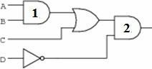
Figure 25: Combinational Circuit

